Supporting document 5

FSANZ’s approach to estimating the residual risk – Proposal P1034

Chemical Migration from Packaging into Food

FSANZ considered two key factors in analysing the residual risk: the risk posed by specific packaging chemicals and the control measures currently used to mitigate this risk:

Risk — The analysis of the risk comprises different elements including:

- inherent risk (i.e. the hazard profile, including the toxicity and nature of the chemical)
- exposure to the chemical (this is dependent upon the food matrix, consumption, market share for packaging type)
- evidence of exposure and migration in the Australia/New Zealand context (from analytical surveys).

Control measures — The analysis of control measures for chemical migration from packaging into food (CMPF ) currently used by industry include:

- market understanding and an estimate of how consistently measures are applied across industry sectors
- knowledge from industry surveys and stakeholder consultations on regulatory and non-regulatory measures used by a cross-section of industry members along the packaging supply chain
- uptake of regulatory requirements currently in place.

The interplay or ‘balance’ of these factors enables a qualitative estimation of the range of residual risk from CMPF (illustrated in Figure 1).

Through this Proposal, FSANZ developed a concept of how to visualise the overall residual risk from CMPF. A risk matrix ‘heat map’ (Figure 2) has been used to qualitatively illustrate the residual risk from a few examples of chemicals associated with different packaging types.

The examples provided in Figure 2 (lead migration from glass; tin from drum metal; vinyl chloride from plastic and acrylonitrile from plastic) indicate how the introduction of control measures for these chemicals, resulted in a reduction in the residual risk. The consequence of introducing control measures is an overall reduction of the residual risk. This is denoted by a shift from the red zone (high residual risk) to the green zone (low residual risk) on the residual risk heat map.
This has been verified through evidence from FSANZ’s survey work.
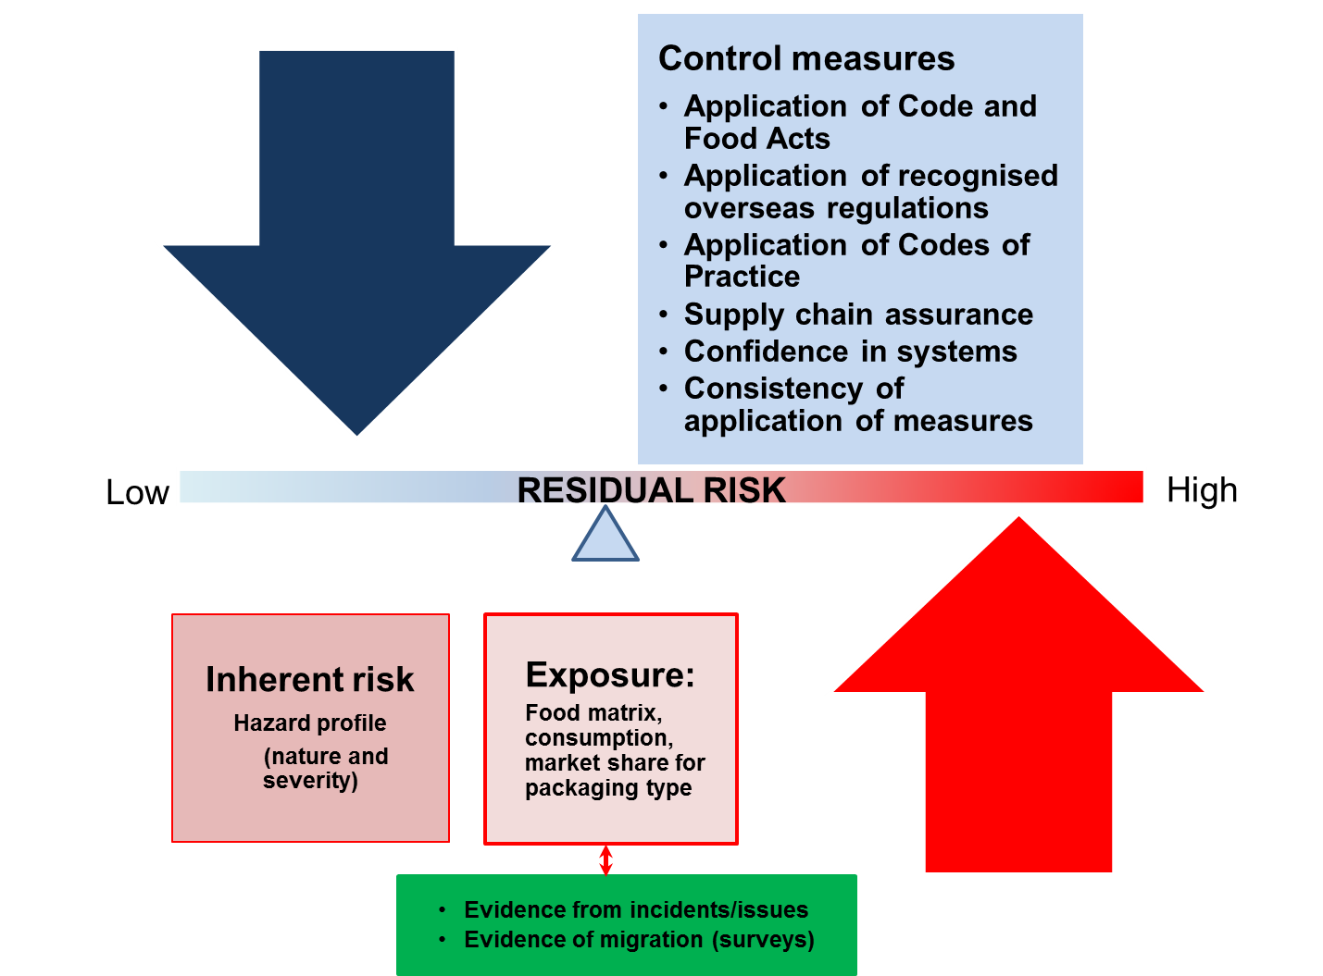

Figure 1: Illustration of the balance of factors affecting the residual risk from CMPF.

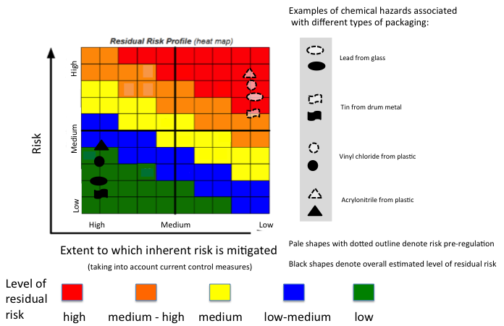
Figure 2: Qualitative estimate of the residual risk from chemicals associated with different packaging types

Control measures used by industry include compliance with regulatory measures (specific maximum levels in Standard 1.4.1, introduced post-1975) and also adherence to non-regulatory measures such as Good Manufacturing Practice, guidelines or codes of practice.
Survey of chemical migration from packaging into food packaging materials in Australian food (acrylonitrile and vinyl chloride; http://www.foodstandards.gov.au/science/surveillance/pages/surveyofchemicalmigr5148.aspx);20th Australian Total Diet Survey (tin; http://www.foodstandards.gov.au/publications/Pages/20thaustraliantotaldietsurveyjanuary2003/20thaustraliantotaldietsurveyfullreport/Default.aspx); 23rd Australian Total Diet Survey (lead; http://www.foodstandards.gov.au/publications/pages/23rdaustraliantotald5367.aspx).

